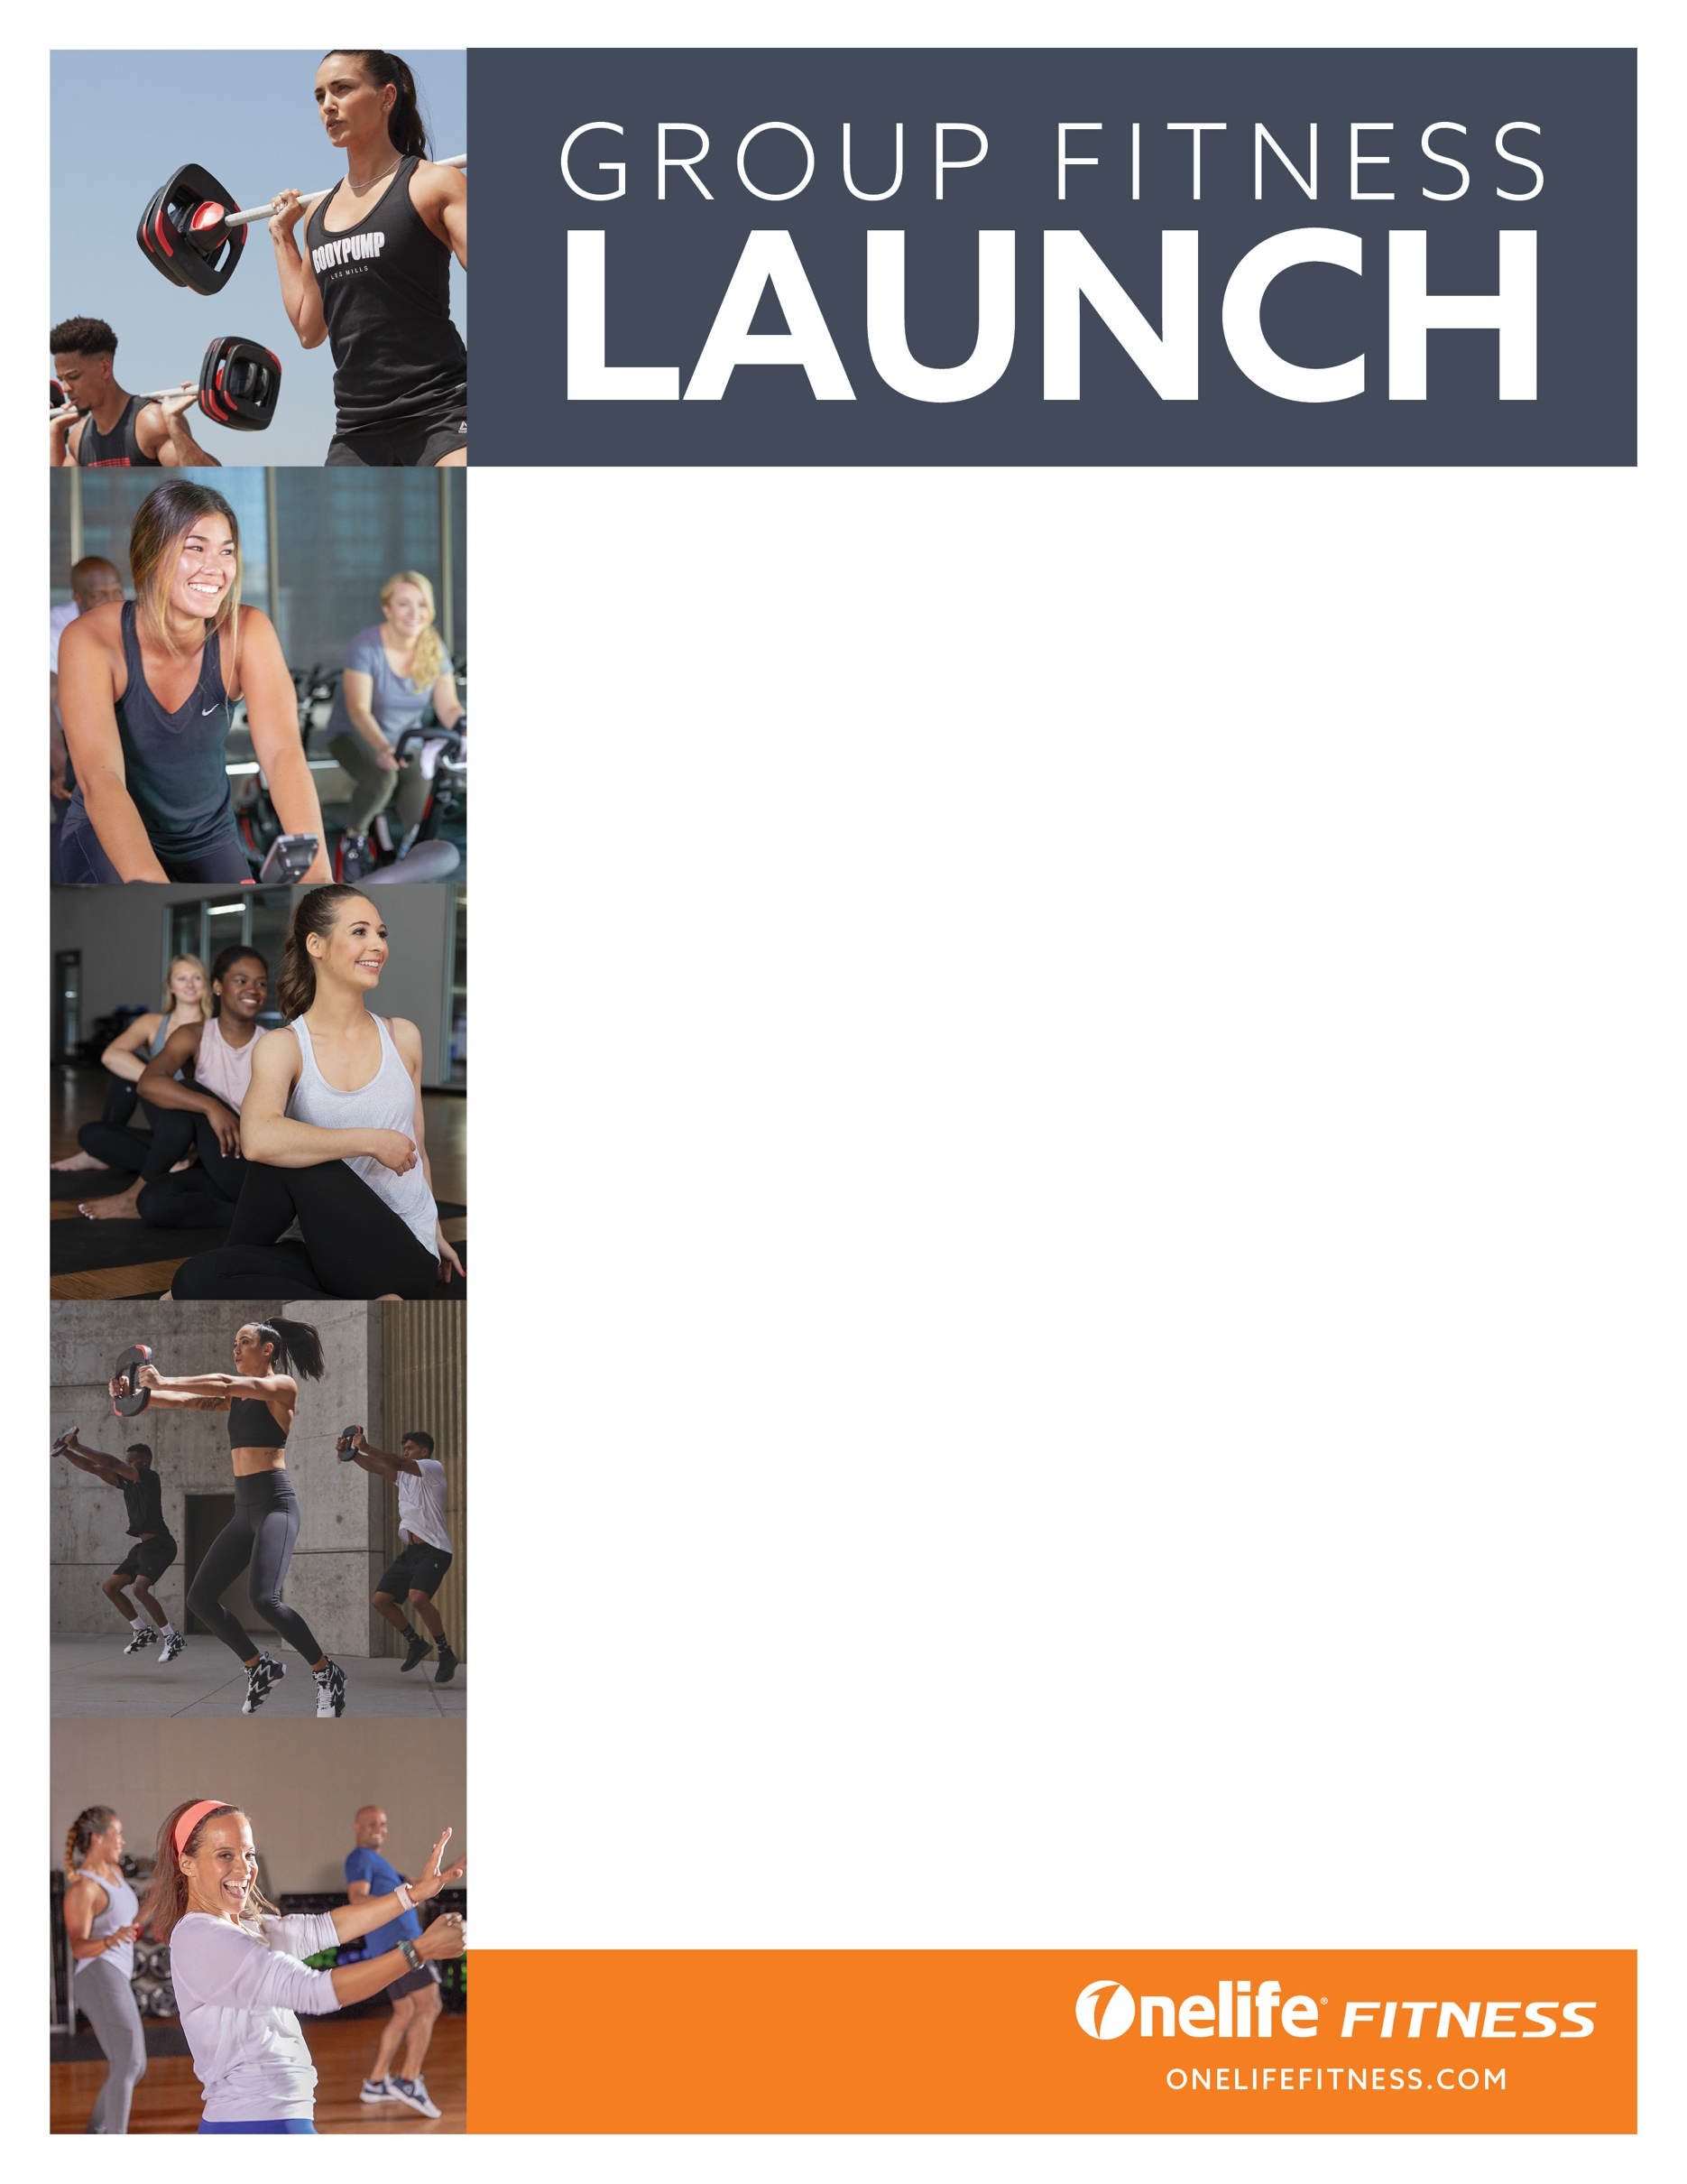

**ONELIFE FITNESS BRAMBLETON**

42365 Soave Dr, Suite 100

**Brambleton, VA**

**703.774.9500**

Sweat all summer long with all your favorite

Group Fitness Classes!

**SATURDAY, JANUARY 7TH**

• 8am BodyStep

• 9am BodyCombat

• 10am CXWorx

• 10:30am BodyPump

**SUNDAY, JANUARY 8TH**

• 8am BodyFlow

• 9am BodyCombat

• 10am CXWorx

• 11am BodyVive

**SUNDAY, JUNE 25TH**

• 8AM Cycle

• 10AM Zumba

**For more information please contact Group Exercise Director, Juli Presley at jpresley@sportandhealth.com.**