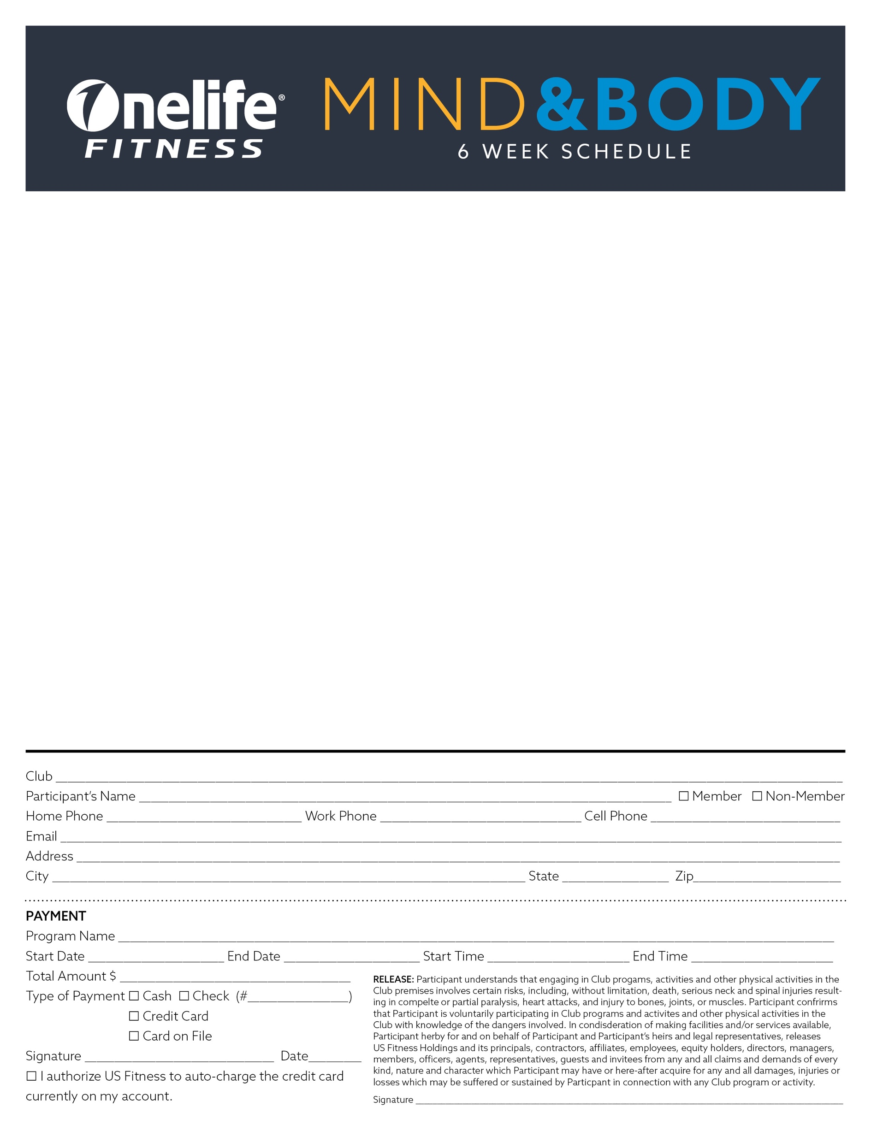

Tysons Fall 2015

Mind & Body - Tysons Sport&Health
8250 Greensboro Dr. • McLean, VA 22102 • onelifefitness.com
Small Group Sessions
Monday | Tuesday | Wednesday | Thursday | Friday | Saturday | Sunday
 | Start your  Motr:  6:10-6:55am  Fay |  | PILATES: APPARATUS Level 2  6:00-6:55am
PILATES: APPARATUS Level 2  8:30-9:25am  Fay |  | PILATES: APPARATUS Level 2  9:00-9:55am  Fay |  |  |  | PILATES: APPARATUS Level 2  9:00-9:55am  Kris

PILATES:

Apparatus

Level 2

7:00-7:55pm
Kris
Club Hours: Mon-Thurs: 5:00am-11:00pm • Friday: 5:00am-10:00pm • Saturday: 7:00am-8:00pm • Sunday: 8:00am-8:00pm
Visit onelifefitness.com/programs to register!
New to our Mind/Body Program?
Do the first-timers package first to see if Pilates group setting is right for you.
Get 3 one-on-one sessions for only $199!
Email Fay Grove at fgrove@sportandhealth.com

PILATES Group
For group pricing please email:
fgrove@sportandhealth.com

Cancelation policy: Please provide at least 48-hour notice to your trainer otherwise you are responsible for the payment of the session.

For more information, email Jen Echols at jen.echols@onelifefitness.com

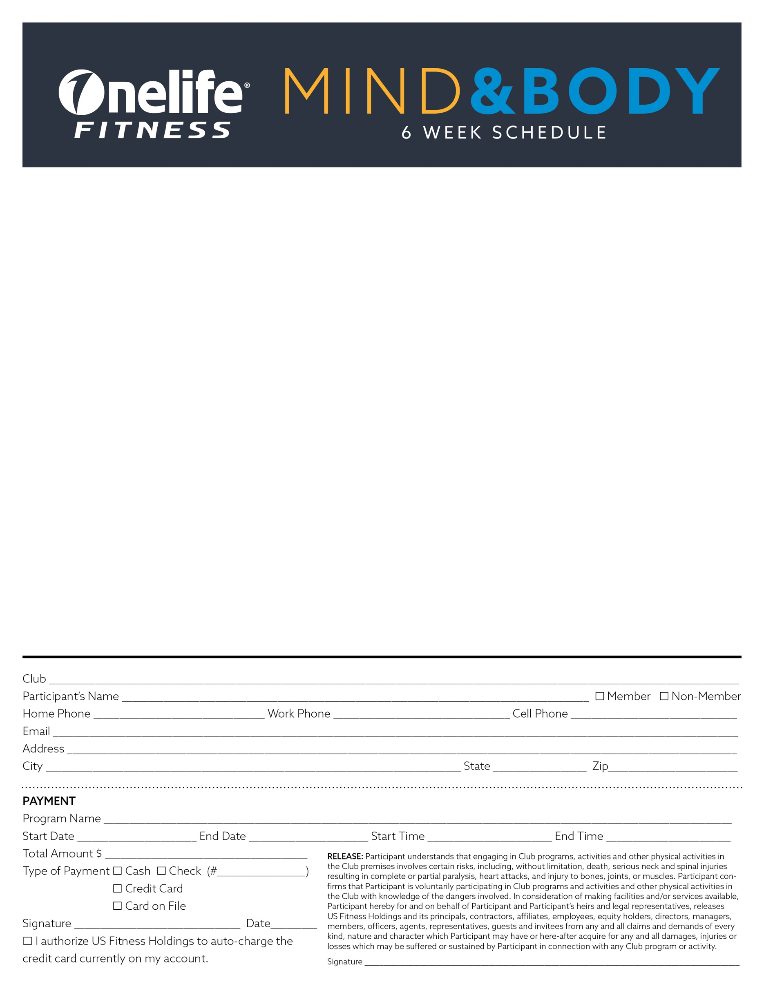

Pilates: Apparatus: This Level 1 class could be just what you are looking for to change your fitness regime. The PILATES Reformer and other apparatus are for every BODY and it’s guaranteed you won’t be bored! Hundreds of exercises in supine, prone, kneeling & standing on a spring-loaded carriage for a full-body workout.

Start your Motr: A 45-minute full body workout that will challenge your balance, strength, stamina. This roller is stable yet provides an unpredictable surface for cardio and plyometric exercises. The structure of the MOTR, with the rounded surface and two independent pulleys, create an environment in which balance, proprioception and selective loading can stimulate the body in numerous ways and will help create myofascial balance.

Yoga: Basics: Perfect course for FIRST-TIMERS to Yoga. Learn a step-by-step method of doing yoga postures customized for your body. Props and preparatory poses will guide the way. In this hands-on series, you will find your functional flexibility, strength and balance while building stronger bones.

For more information contact Mind/Body Director, Fay Grove at 703-637-7474 or email
fgrove@sportandhealth.com.

